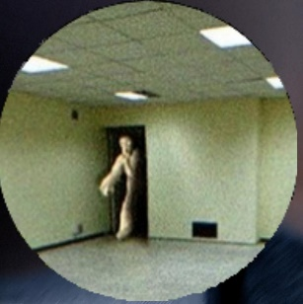 BACKROOM AND MALENA KI PICTURE MENTION KARDI HAI

BAQI JOE AND IRWAN KI KOI SI BHI UTHALOU FOLDER SAI

xxxxxxxxxxxxxxxxxxxxxxxxxxxxxxxxxxxxxxxxxxxxxxxxxxxxxxxxxxxxxxxxxxxxxxxxx

**Backroom Archive**

**UK**

*"Brilliant experience working with them! They took care of YouTube automation and editing effortlessly, delivering polished, engaging videos that made a real difference. Truly reliable and skilled!"*

**JOE**

DUBAI

*"An absolute pleasure to work with! They developed a clear and effective content strategy while delivering top-notch artwork that exceeded my expectations. Their creativity, professionalism, and attention to detail truly set them apart."*

 **Malena**

USA

*Amazing experience working with them! They set up an automated flow on Power Automate flawlessly, streamlining my processes and saving me so much time. Highly skilled and dependable*

**IRWAN**

Indonesia

*Exceptional work! They set up seamless email automation systems that saved me time and improved efficiency. Their expertise, attention to detail, and professionalism made a real difference in my business operations*

Xxxxxxxxxxxxxxxxxxxxxxxxxxxxxxxxxxxxxxxxxxxxxxxxxxxxxxxxxxxxxxxxxxxxxxxxxxxxxxxxxxxxxxxxxx

#IN DONO KO REPLACE KARDO WEBSITE KA ORIGINAL TEXT

*Genuine feedback from those who matter most—our valued clients*

**What Our** Clients Say:

**Real Experiences**, Real Impact